

CAPSTONE PROJECT REPORT
Report 2 – Project Management Plan

– Hanoi, Spring 2026 –

Record of Changes

A. Record of Changes 2
I. Record of Changes 3
II. Project Management Plan 4
1. Overview 4
1.1. Scope & Estimation 4
1.2. Project Objectives 5
1.2.1. Quality 5
1.2.2. Project Objectives 6
1.2.3. Team Objectives 6
1.3. Project Risks 6
2. Management Approach 7
2.1. Project Process 7
2.1.1. Initial Planning Phase 8
2.1.2. Iteration 1: Core Customer & Authentication Features 8
2.1.3. Iteration 2: Reception, Workshop & Service Operations 8
2.1.4. Iteration 3: Management, Reporting & Billing 9
2.1.5. Deployment and Final Review 9
2.2. Quality Management 9
2.2.1. Document Standards 10
2.2.2. Coding Standards 10
2.3. Training Plan 10
3. Project Deliverables 11
4. Responsibility Assignments 12
5. Project Communications 13
6. Configuration Management 13
6.1. Document Management 13
6.1.1. Documentation Tools 13
6.1.2. Document Storage and Organization 13
6.1.3. Document Version Control 13
6.1.4. Document Delivery 14
6.2. Source Code Management 14
6.2.1. Version Control System 14
6.2.2. Branching Strategy 14
6.2.3. Commit Rules 14
6.2.4. Code Review and Merge Process 14
6.2.5. Conflict Handling 15
6.2.6. Communication Tools 15
6.3. Tools & Infrastructures 15

Record of Changes

Date | A*  M, D | In charge | Change Description
14/01/2026 | A | KhanhNN | Create new document
21/01/2026 | M | KhanhNN | Write document
28/01/2026 | M | KhanhNN | Write document
*A - Added M - Modified D - Deleted

Project Management Plan

Overview

Scope & Estimation
# | WBS Item | Complexity | Est. Effort (man-days)
1 | Authenticate User |  | 20
1.1 | Register Account | Medium | 5
1.2 | Sign In Account | Medium | 5
1.3 | Sign Out Account | Simple | 2
1.4 | Change Password | Medium | 4
1.5 | Forgot Password | Medium | 4
2 | Manage Personal Service |  | 18
2.1 | View Landing Page | Simple | 3
2.2 | View Service History | Medium | 5
2.3 | Track Service Progress | Complex | 10
3 | Manage Personal Bookings | Complex | 10
4 | Update Personal Profile |  | 10
4.1 | View User Profile | Simple | 3
4.2 | Manage Personal Profile | Medium | 7
5 | View Attendance Record |  | 16
5.1 | Daily Attendance (Check-in / Check-out) | Complex | 8
5.2 | View My Schedule | Medium | 8
6 | Process Booking Request |  | 25
6.1 | Book Service Appointment | Complex | 10
6.2 | Create a Walk-in Booking | Complex | 15
7 | Manage Confirm Booking | Complex | 18
7.1 | Apply Promotion to Booking | Medium | 8
7.2 | Queue, reorder, swap Booking | Complex | 10
8 | Check-in Customer Vehicle | Complex | 12
9 | Manage Service Ticket |  | 53
9.1 | Confirm Payment Status | Medium | 8
9.2 | Billing by Service Ticket | Complex | 12
9.3 | Create Service Ticket | Complex | 15
9.4 | Update Service Ticket | Complex | 10
9.5 | View Service Ticket | Complex | 8
10 | Manage Customer Vehicle | Medium | 10
11 | Manage Customer Profile | Medium | 8
12 | Manage Customer Queue | Medium | 10
13 | Notify Customer Reminder |  | 18
13.1 | Integrate Zalo OA API | Complex | 10
13.2 | Send Booking Reminder Message | Simple | 4
13.3 | Send Service Status Notification | Simple | 4
14 | Manage Service Quotation |  | 35
14.1 | View Service Requests | Simple | 5
14.2 | Create & Customize Service Estimate | Complex | 15
14.3 | Create Supplementary Service Quotation | Complex | 10
14.4 | Stock Allocation | Medium | 5
15 | Work Assigned Management | Complex | 12
16 | Manage Work Shifts | Complex | 12
17 | Manage Staff Profile |  | 18
17.1 | View My Work History | Simple | 5
17.2 | View Assigned Tasks | Medium | 7
17.3 | Manage Employee Profiles | Simple | 6
18 | Manage Service Price | Medium | 8
19 | Manage Customer Promotion | Complex | 7
20 | Manage Customer Service History |  | 15
20.1 | View Customer Service History | Medium | 5
20.2 | View Dashboard | Complex | 10
21 | Manage User Accounts | Medium | 5
21.1 | Manage Roles & Permissions | Complex | 10
22 | Manage Customer Feedback | Simple | 3
23 | Manage Personal Vehicles | Medium | 4
24 | Manage System Report | Complex | 5
24.1 | View Performance Reports | Simple | 2
25 | Submit Service Feedback | Simple | 2
26 | Warehouse Management | Complex | 30
26.1 | Stock Entry & Issue | Complex | 16
26.2 | Warehouse Inventory | Medium | 6
26.3 | Catalog / Item / Brand | Medium | 5
26.4 | Excel Import/Export | Simple | 3
Total Estimated Effort(man-days): 367

Project Objectives

Quality

# | Testing Stage | Test Coverage | No. of Defects | % of Defect | Notes
1 | Requirement Review | 80% | ≤ 20 |  | Review and validate functional requirements, use case list, and scope definition documents to ensure clarity, completeness, and consistency before development.
2 | Unit Test | 80% | ≤ 20 |  | Unit tests are written and executed by developers to verify that individual modules (e.g., login, booking, service ticket) function correctly according to the design.
3 | Integration Test | 95% | ≤ 100 |  | Test the interaction between integrated modules such as booking management, service tickets, technician assignment, and billing to ensure smooth data flow across the system.
4 | System Test | 100% | ≤ 20 |  | Comprehensive testing of the complete web-based system to verify functionality, behavior, performance, and compliance with the defined functional requirements of the garage management system.
5 | User Acceptance Test (UAT) | 100% | ≤ 5 |  | End users (store owner, receptionist, technician) perform testing based on real operational scenarios such as walk-in booking, vehicle check-in, service execution, and payment confirmation.

Project Objectives
- The project will be completed according to the planned schedule.
- The project will be completed within the allocated effort of 367 man-days.
- The system will fully satisfy the defined functional and non-functional requirements.
- The project will ensure acceptable quality standards through defined testing stages and reviews.

Team Objectives
- The team completed the project before April 30th 2026.
- Each team member follows the assigned roles and tasks according to the project plan.
- Each team member improves both technical skills (system design, implementation, testing) and soft skills (communication, teamwork, time management).
- The team successfully applies a structured software development process throughout the project lifecycle.
- The team collaborates effectively to ensure system quality and project success.

Project Risks

# | Risk Description | Impact | Possibility | Response Plans
1 | Lack of experience with complex business workflows | High | Medium | Analyze business processes carefully at the beginning of the project. Break down complex workflows into smaller tasks. Conduct regular reviews with stakeholders to validate workflow logic.
2 | Inaccurate effort estimation for core modules | High | High | Prioritize core features early in the development phase. Continuously track actual effort versus planned effort and adjust the schedule accordingly. Reserve buffer time for critical modules such as Service Ticket and Service Estimation.
3 | Integration issues between frontend and backend | High | Medium | Define clear API contracts and data formats early. Perform incremental integration testing after completing each major module. Maintain consistent documentation for APIs and data models.
4 | Requirement changes during development | Medium | High | Establish a clear change request process. Evaluate the impact of each change on timeline and effort before approval. Focus on implementing core features first and defer optional features if needed.
5 | Data inconsistency between customer, booking, and vehicle records | Medium | Medium | Design a centralized data model with proper relationships and constraints. Apply validation rules at both application and database levels to prevent incorrect data entry.
6 | Security vulnerabilities in authentication and role management | High | High | Apply secure authentication mechanisms, password encryption, and role-based access control. Conduct security reviews and testing for authentication, authorization, and sensitive data access.
7 | Performance issues when handling multiple concurrent bookings and service updates | Medium | Low | Optimize database queries and apply indexing where necessary. Perform performance testing for booking and service-related functions. Monitor system performance during development.
8 | Team members’ unfamiliarity with tools or technologies used in the project | Medium | Medium | Allocate time for self-learning and technical discussions. Share knowledge through documentation and internal demos. Assign tasks based on individual strengths and learning progress.
9 | Lack of experience with modern web frameworks due to the academic curriculum. | High | High | Conduct a mandatory self-training phase for all members before the official project kickoff. Divide the team into Frontend and Backend roles early so members can focus their learning efficiently.

Management Approach

Project Process
In this project, we apply the Iterative Incremental development model to ensure flexibility, early delivery of core functionalities, and continuous improvement based on feedback. This approach allows the team to gradually build the system while managing risks effectively, especially for complex business workflows such as booking management, service ticket processing, and workshop operations.
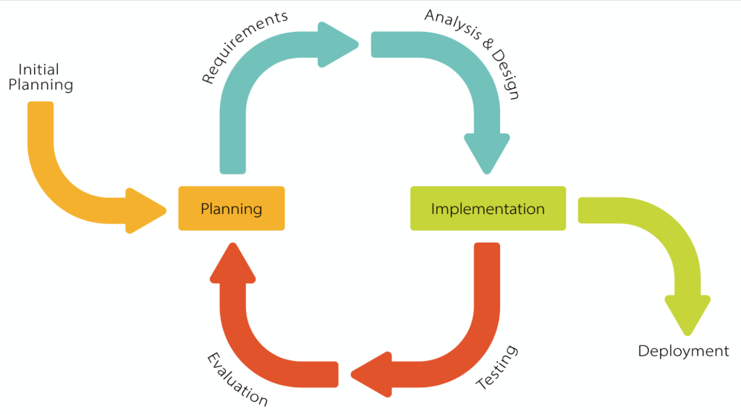
Figure 2-1: Project Process
The project officially starts on January 5th 2026 and is divided into five main iterations, each focusing on specific functional modules of the Garage Management System.

Initial Planning Phase
Duration: [Week 1 – Week 3]
Focus:
- Define project scope, objectives, and system boundaries
- Identify stakeholders and user roles
- Collect and analyze functional and non-functional requirements
- Design high-level system architecture and database schema
- Plan iterations, task allocation, and estimated effort

Iteration 1: Core Customer & Authentication Features
Duration: [Week 4 – Week 5] (26/01/2026 – 08/02/2026)
Focus:
- Develop Authentication & Account Management features
- Implement Customer Services modules such as:
  - Service catalog viewing
  - Online service appointment booking
  - Personal booking management
  - Vehicle management and service history
- Implement basic UI and navigation flow
- Perform unit testing and integration testing for Iteration 1 features
- Fix bugs and refine functionalities based on internal feedback

Iteration 2: Booking & Reception Operations
Duration: [Week 6 – Week 7] (09/02/2026 – 01/03/2026) (includes Lunar New Year break)
Focus:
- Develop Reception & Booking Management modules:
  - Walk-in booking
  - Vehicle check-in
  - Service ticket creation
  - Technician assignment
- Implement Workshop & Technician Operations
  - Task assignment
  - Service status updates
  - Technical notes management
- Develop Service Advisory & Estimation features
- Conduct integration testing across customer and staff workflows
- Fix defects and optimize system performance

Iteration 3: Service Ticket & Workshop Operations
Duration: [Week 8 – Week 9] (02/03/2026 – 15/03/2026)
Focus:
- Develop Service Ticket Management:
  - Create, update, and track service tickets
  - Assign technicians
- Implement Workshop operations:
  - Task assignment and tracking
  - Service progress updates
  - Technician notes
- Develop Service Advisory & basic estimation features
- Ensure end-to-end workflow from check-in service execution
- Conduct integration testing across modules

Iteration 4: Estimation, Warehouse & Advanced Operations
Duration: [Week 10 – Week 11] (16/03/2026 – 29/03/2026 )
Focus:
- Implement Service Quotation & Estimation:
  - Create and update estimates
  - Supplementary service requests
- Develop Warehouse Management:
  - Stock entry, stock issue, return handling
  - Inventory tracking
  - Stock allocation for service tickets
- Integrate estimation with inventory system
- Optimize system performance for complex workflows
- Conduct integration testing for warehouse and estimation modules

Iteration 5: Management, Billing & System Administration
Duration: [Week 12 – Week 13] (30/03/2026 – 12/04/2026 )
Focus:
- Implement Management features:
  - Staff management and work shifts
  - Role & permission management
- Develop Pricing & Promotion modules
- Implement Billing & Payment processing
- Build Dashboard & Reporting features
- Conduct system testing and user acceptance testing (UAT)
- Fix major defects and improve usability

Finalization & Review
Duration: Week 14 (13/04/2026 – 20/04/2026)
Focus:
- Perform final system testing and bug fixing
- Review and finalize project documentation
- Clean up source code and optimize performance
- Prepare user manuals and presentation materials

Deployment & Maintenance
Duration: Week 15 (21/04/2026 – 29/04/2026)
Focus:
- Deploy system to production environment
- Monitor system performance and stability
- Fix post-deployment issues
- Provide basic maintenance and support

Quality Management
Improving project quality and achieving quality objectives require a systematic quality management approach that is integrated throughout the project lifecycle. Since the project follows an iterative incremental methodology, quality assurance activities are continuously applied in each iteration.

Define Clear Quality Objectives

The project aims to deliver a stable, reliable, and user-friendly garage management system that meets functional requirements and supports real-world workshop operations. Quality objectives include correctness, usability, maintainability, and performance.

Requirements Gathering and Analysis

Quality assurance begins at the requirement phase. Business requirements are carefully analyzed to ensure they are complete, consistent, and unambiguous. Clear use case definitions and scope boundaries help prevent misunderstanding and scope creep.

Defect Prevention

Proactive defect prevention measures are applied throughout development, including:
- Reviewing requirement and design documents before implementation
- Applying consistent coding standards and best practices
- Conducting peer reviews for critical features
- Designing modular components to reduce complexity and dependency

Reviewing

Regular reviews are conducted at multiple levels:
- Requirement and design reviews during analysis
- Code reviews during implementation
- Iteration reviews at the end of each development cycle
These reviews help detect issues early and improve overall system quality.

Unit Testing

Developers perform unit testing to verify that individual functions and modules work correctly according to the design. Unit tests focus on authentication logic, booking workflows, service ticket processing, and data validation.

Integration Testing

Integration testing is conducted to ensure that different modules (Customer, Receptionist, Technician, Manager) interact correctly. Special attention is given to workflows such as booking, check-in, service ticket, billing.

System Testing

System testing evaluates the entire application as a complete system. Functional testing, workflow validation, and basic performance checks are conducted to ensure the system meets all specified requirements.

Risk Management

Potential risks related to technical complexity, data consistency, and integration issues are continuously monitored. Mitigation plans are prepared to minimize their impact on system quality.

Documentation and Knowledge Sharing

Project documents are kept up-to-date and shared among team members to avoid knowledge silos. Clear documentation supports maintenance and future system extension.

Document Standards
- All project documents follow the FPT template
- Fonts, font sizes, alignment, and formatting are standardized
- Diagrams and tables are clearly labeled and consistently styled

Coding Standards
- Package, class, method, and variable names are clear and meaningful
- Naming conventions are consistently applied across the project
- Code is structured for readability, maintainability, and reuse
- Comments are added for complex logic and business rules

Training Plan

Training Area | Participants | When, Duration | Waiver Criteria
Java Spring Boot | Backend Development Team | 01/12/2025 - 30 days | Mandatory
ReactJs | Frontend Development Team | 01/12/2025 - 30 days | Mandatory
Testing | Tester | 01/12/2025 - 30 days | Mandatory

Project Deliverables

# | Deliverable | Due Date | Notes
1 | Report1_Project Introduction | 21/01/2026 | ProductBackground  ExistingSystems  BusinessOpportunity  ProductVision  ProjectScope&Limitations
2 | Report2_Project Management Plan | 28/01/2026 | ManagementApproach  ProjectDeliverables  ResponsibilityAssignments  ProjectCommunications  ConfigurationManagement
3 | Report3_Software Requirement Specification | 05/02/2026 | BusinessRules  UseCaseDiagram&UseCase  Description  FunctionalRequirements  Non-FunctionalRequirement
4 | Report4_Software Design Document | 05/03/2026 | Project&SRSReview,Project  Review  SystemArchitecture  Back-endArchitecture  Front-endArchitecture
5 | Initial Planning Prototype | 25/01/2026
6 | Code Iteration 1 Plan and Prototype | 08/02/2026 | DetailedDesign  Code&UnitTest  Integration&SystemTestCases
7 | Code Iteration 2 Plan and Prototype | 01/03/2026 | DetailedDesign  Code&UnitTest  Integration&SystemTestCases
8 | Code Iteration 3 Plan and Prototype | 15/03/2026 | DetailedDesign  Code&UnitTest  Integration&SystemTestCases
9 | Code Iteration 4 Plan and Prototype | 29/03/2026 | DetailedDesign  Code&UnitTest  Integration&SystemTestCases
10 | Code Iteration 5 Plan and Prototype | 12/04/2026 | DetailedDesign  Code&UnitTest  Integration&SystemTestCases
11 | Report5_Test Documentation | 16/04/2026 | TestModel  TestPlan  TestCases  TestReports
12 | Report6_Software User Guides | 17/04/2026 | DeliverablePackage  InstallationGuidesUser  Manual
13 | Report7_Final Project Report | 25/04/2026 | Includesallthefinalprojectdocuments  (completedReportsNo.1-6,bothsoft  copy&hardcopy)  PresentationSlide  SourceCode
14 | Source Code and Database Script | 26/04/2026

Responsibility Assignments
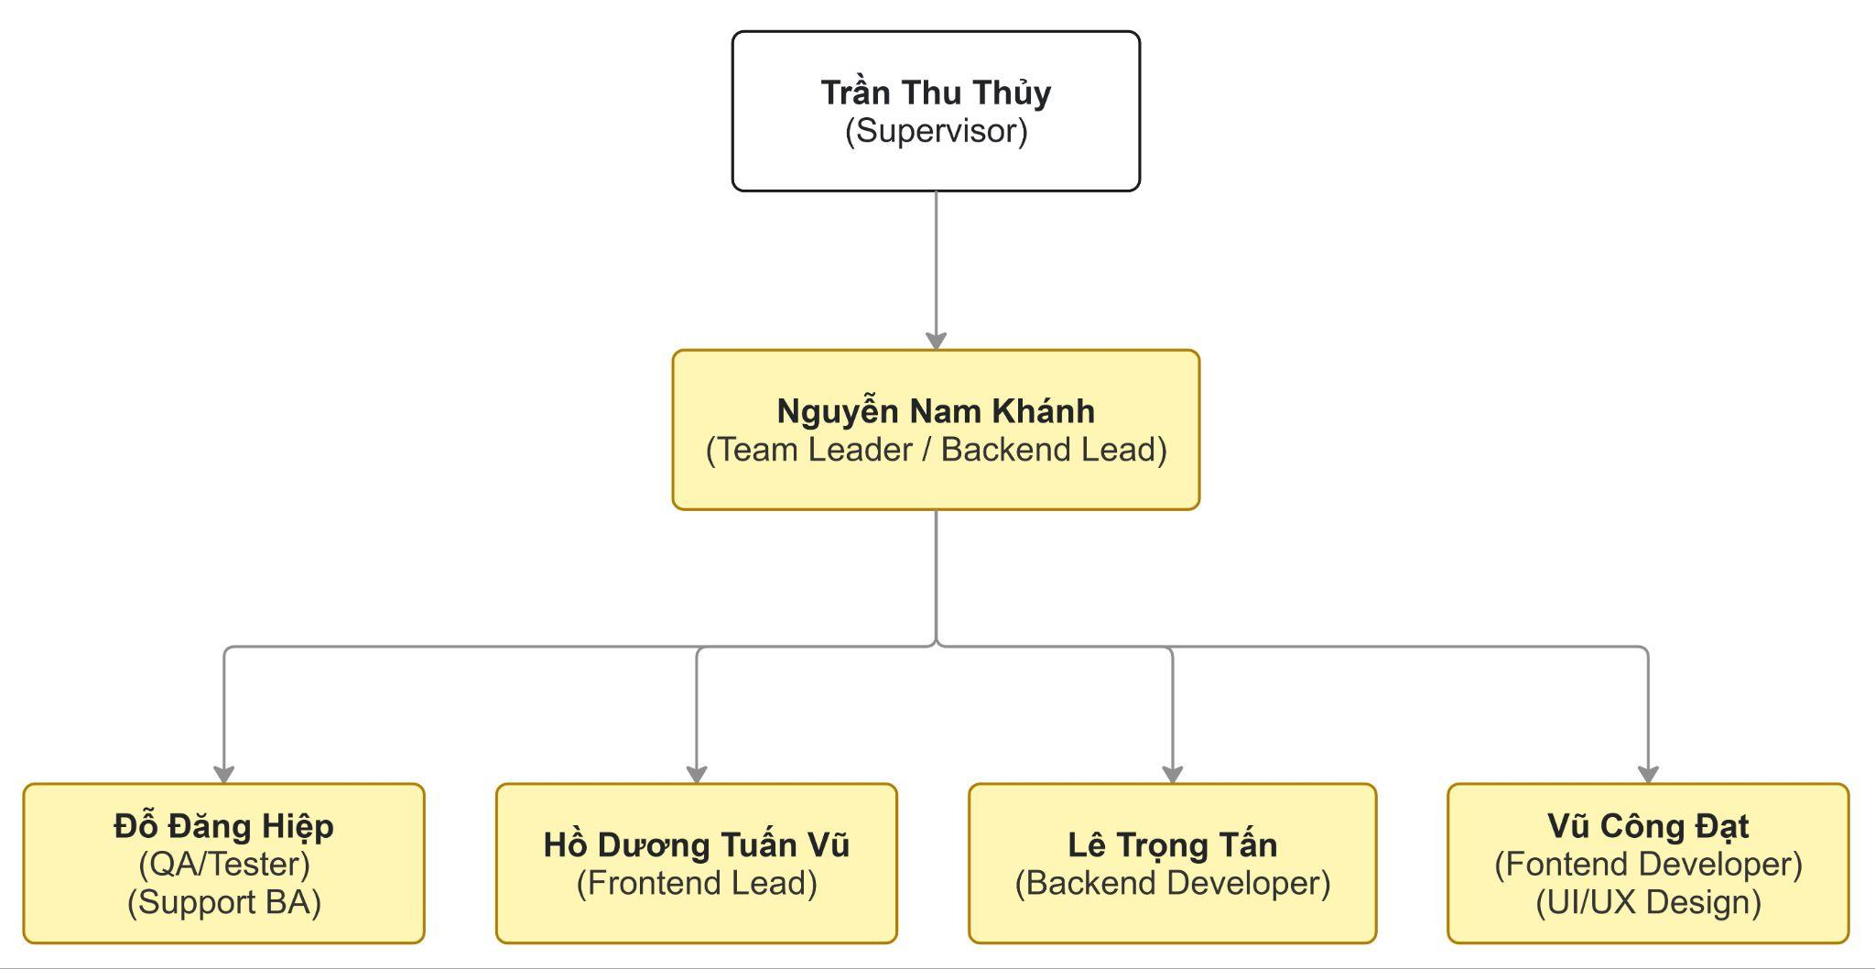
Figure 4-1: Responsibility Assignments
R~Responsible; A~Accountable; C~Consulted; I~Informed;

# | Responsibility | PM | BA | Designer | Frontend dev | Backend dev | Tester | Lecturer | Garage owner
1 | Create project chapter | R/A | C | C | C | C | C | C | I
2 | Prepare Project Introduction Document | R/A | R/C | I | I | I | I | I/C | C
3 | Project Planning and Tracking | R/A | C | I | I | I | I | I/C | I/C
4 | Create SRS Document | A | R | C | C | C | I/C | I/C | I/C
5 | Create SDD Document | A/C | C | C | R | R | I/C | I/C | I
6 | Design Prototype | C | A/C | R | I | I | I | C | I/C
7 | Database Analyse | I/C | C | I/C | I/C | R/A | I/C | C | I/C
8 | Implement Coding Backend | I/C | C | I | C | R/A | I/C | C | I
9 | Implement Coding Frontend | C | C | I | R/A | C | I/C | C | I
10 | Create Test Scenario / Test Case | I/C | C/A | I/C | R | R | R | C | I
11 | Perform Testing | I/C | I | I | C | C | R/A | I/C | I
12 | Create Product Backlog | R | A | I/C | I/C | I/C | I/C | C | I
13 | Create Iteration Backlog | R | A | I/C | I/C | I/C | I/C | C | I
14 | Create User Manual | A | R | C | C | C | C | C | I/C
15 | Prepare Weekly Report and Meeting Report | R/A | R | I | I | I | I | I | I

Project Communications

Communication Item | Who/ Target | Purpose | When, Frequency | Type, Tool, Method(s)
Weekly Meeting | All team members and lecturer | Review and determine next week’s job | 20:00 Every Wednesday | Google Meet
Team daily meeting | All team members | Report project’s progress and status of each member’s work each day. | 21:00 every Monday and Friday, 22:00 Every Tuesday, Thursday | Google Meet
Team daily working | All team members | Work together | Everyday | Messenger, Zalo, Google Sheet
Unscheduled meeting | All team members | Quick meet if serious issues detected | Quick meet if serious issues detected | Google Meet

Configuration Management
Configuration Management is applied to control, track, and manage changes of project documents and source code during the software development lifecycle. This helps ensure consistency, traceability, and collaboration among team members.

Document Management
To effectively manage project documents and their versions, the following document management process is applied:

Documentation Tools
The project uses the following tools to create, edit, and store documents:
- Google Docs, Sheets, Drive
- Miro
- Visual Paradigm
These tools support collaboration and version tracking.

Document Storage and Organization
All project documents are stored centrally on Google Drive.
Documents are organized into separate folders based on document type, such as:
- Project Planning
- SRS (Software Requirements Specification)
- SDD (Software Design Document)
- Test Documents
- User Manual
Access permissions are controlled to ensure only authorized members can edit critical documents.

Document Version Control
Newly created documents start with version 1.0.
Edited documents will be updated as version 1.x
Major changes will increase the version number to 2.0, 3.0, etc.
Change history is recorded directly in the document or via Google Drive version history.

Document Delivery
All final reports are delivered to the supervisor via Google Drive.
Continuous integration is applied for the final report by merging all related documents from planning, analysis, design, implementation, and testing phases.

Source Code Management
To manage the project source code and its changes effectively, the following source code management process is applied

Version Control System
- Git is used as the version control system.
- The source code repository is hosted on GitLab (or GitHub, depending on team decision).

Branching Strategy

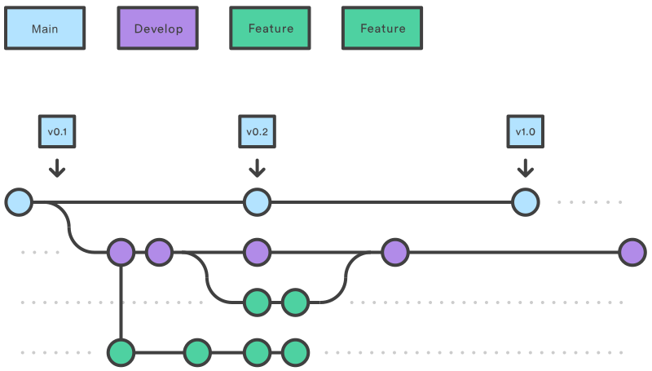
Figure 6-1: GitFlow of MST-GMS Project

The project follows the Gitflow branching model, including:
- Main:
Contains stable and production-ready source code. Direct commits are not allowed.
- Develop:
Contains the latest development code where features are integrated.
- Feature/*:
Each feature or function is developed in a separate branch.

Commit Rules
- Each commit must have a clear and meaningful message describing the change.
- Commits should focus on a single task or function.
- Commit format example:
  - <type>: <short description>

Code Review and Merge Process
- Before merging code from a feature branch into the develop branch, a code review must be performed.
- Pull Requests (Merge Requests) are used to manage merging.
- The team leader or assigned reviewer is responsible for reviewing and approving the code.
- Squash commits are not allowed to ensure traceability.

Conflict Handling
- If conflicts occur during merging, the team leader coordinates with related members to resolve them.
- Conflicts are resolved carefully to maintain code consistency and system stability.

Communication Tools
To support coordination and quick problem-solving during development:
- Zalo / Messenger / Discord: Daily communication
- Google Meet: Online meetings and code review discussions

Tools & Infrastructures

Category | Tools / Infrastructure
Technology | ReactJs (FrontEnd), Java/SpringBoot (BackEnd)
Database | MySQL
IDEs/Editors | Visual Code, IntelliJ, MySQL Workbench
Diagramming | Visual Paradigm, Miro, ERD plus
Documentation | Google Docs/Sheets/Slides/Drive/Canva
Version Control | GitHub (Source Codes), Google Drive (Documents)
Deployment server | VPS, Docker, Ubuntu
Project management | Google Sheet

